**Gym Management System**

Md. Afik Arber Jahin (210101008), Abdullah Al Fahad (220101010)

Course Code: CSE 2206 Course Title: Database Management systems Sessional

Semester: Summer 2023

*Department of Computer Science and Engineering, Bangladesh Army University of Science and Technology (BAUST)

1. **Introduction**

**A Gym Management System is a software application or platform designed to streamline and simplify the operations and administrative tasks of a fitness center or gym. It provides a comprehensive solution for gym owners, managers, and members to efficiently manage various aspects of the gym's daily activities. This system helps in automating routine tasks, reducing administrative workload, improving member experience, and ultimately enhancing the overall efficiency and profitability of the gym.**

1. **Problem Definition**

**Today, small gym Centers are facing lots of problems as mentioned below: -**

* **It becomes very difficult to retrieve or find the particular information. E.g.: To find out about members fees details, the user has to go through various registers, these results in waste age of time.**
* **It is manual and time consuming.**
* **There are more human errors.**
* **There is difficult to manage the large amount of data in a register or a book.**
* **Searching becomes more difficult.**
* **Maximum chances of losing data.**
* **No security as data can be misplaced or damaged.**
* **Lastly, it was not offering a user-friendly work environment.**

1. **Available Applications**

[**http://localhost/Gym-System/**](http://localhost/Gym-System/)

1. **Stakeholders**

**• Admin**

**• Super Admin**

**• Trainer**

**• Student/Members**

1. **Issues Encountered**

**Error Messages: If you are receiving error messages, note down the exact message and any error codes. This information can be crucial in identifying the problem.**

**Check System Requirements: Ensure that your system meets the minimum requirements for the gym management software. This includes hardware, operating system, and software dependencies.**

**Software Updates: Make sure your gym management software is up to date. Check for any available updates or patches from the software provider.**

**User Access and Permissions: Confirm that you have the necessary user access and permissions to perform the task you're trying to complete. Sometimes issues can arise from insufficient privileges.**

**Data Entry Errors: Double-check the data you've entered into the system. Incorrect data can lead to various issues, including scheduling conflicts, billing errors, and more.**

**Internet Connection: If your gym management system relies on an online connection, ensure that your internet connection is stable and not causing disruptions.  
  
Database Integrity: If your gym management system uses a database, check the integrity of the database. Database corruption can lead to various issues. Back up your data and consider database maintenance.  
  
Clear Cache and Cookies: If the system is web-based, try clearing your browser's cache and cookies. Sometimes, old data can cause issues.  
  
Contact Support: If you've gone through these steps and the issue persists, contact the support team of your gym management software. They may have specific troubleshooting steps or solutions for your problem.  
  
Documentation: Review the user manual or documentation provided by the gym management software to see if it offers any guidance on the issue you're facing.**

1. **System Architecture**

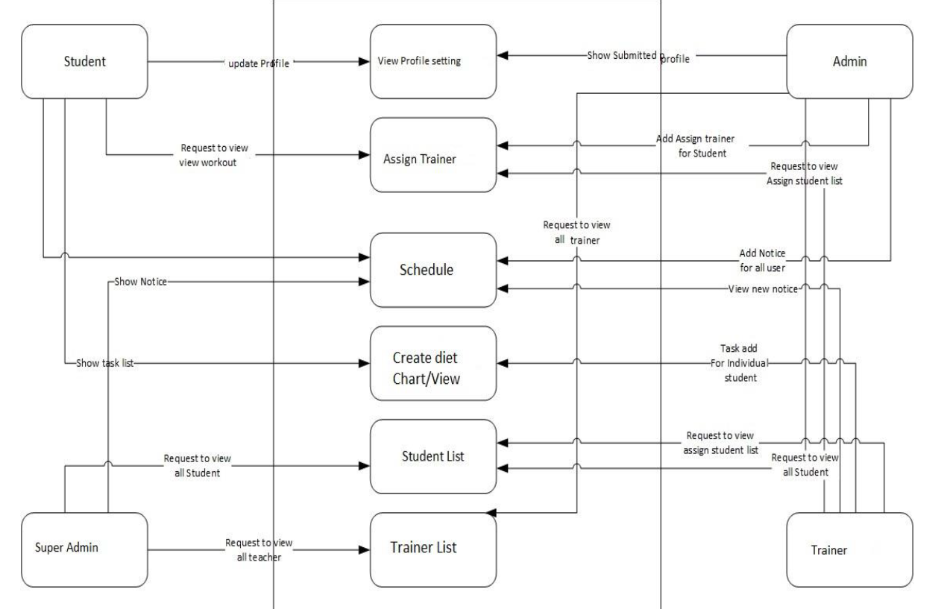

1. **Database Design**

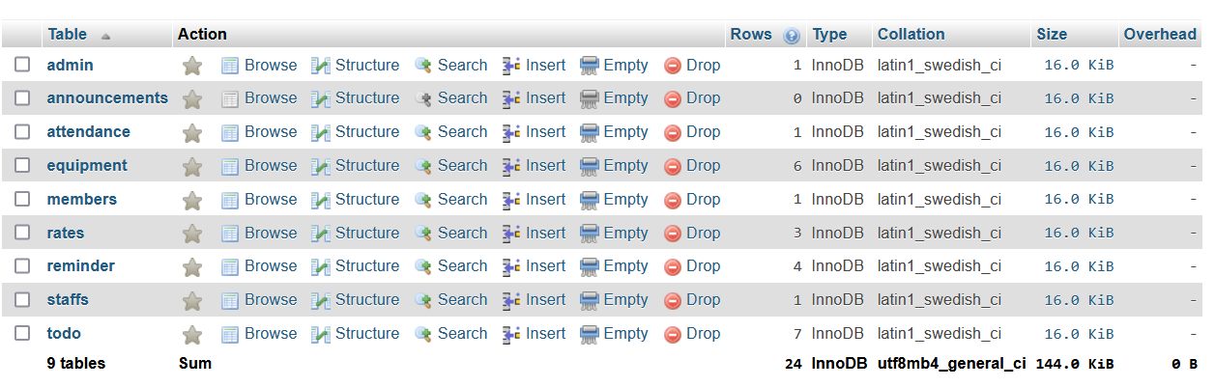



1. **Tools and Technologies**

**• Operating System - Windows, Linux, Mac**

**• Language – PHP**

**• Database - MySQL**

**• Development tools – Visual Studio Code**

1. **Implementation**

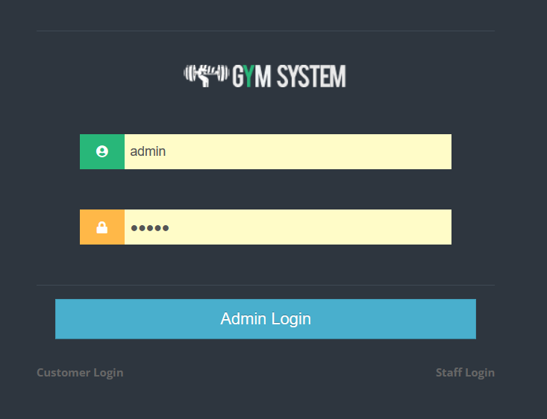

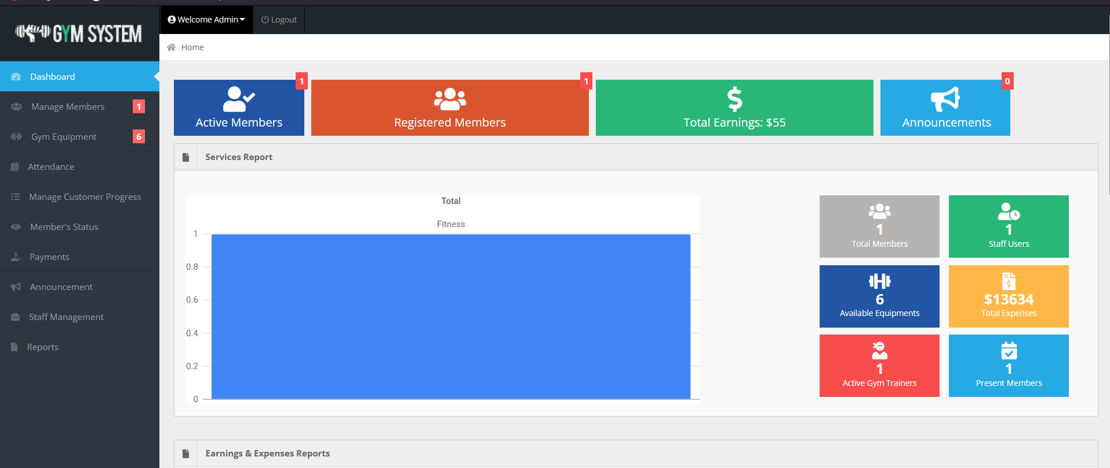

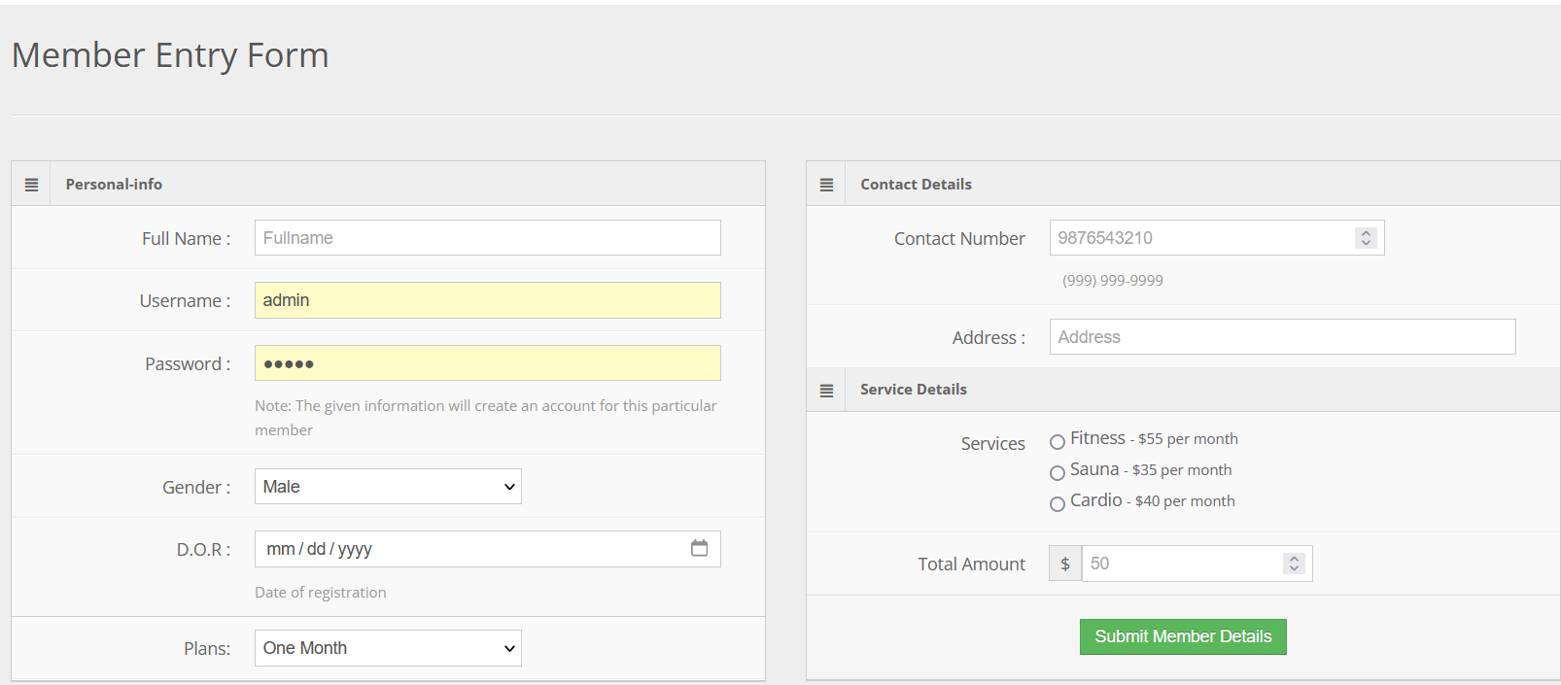

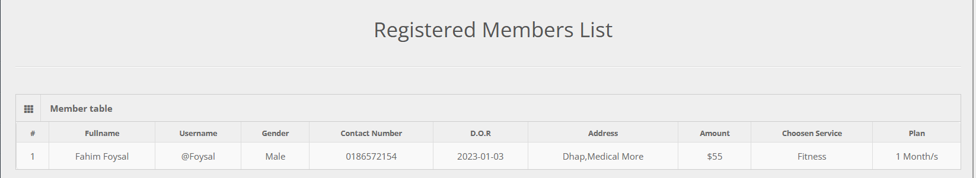

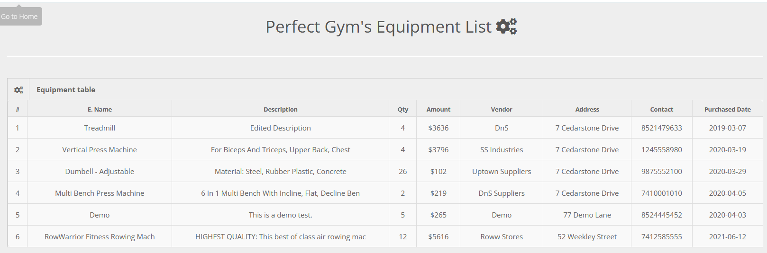



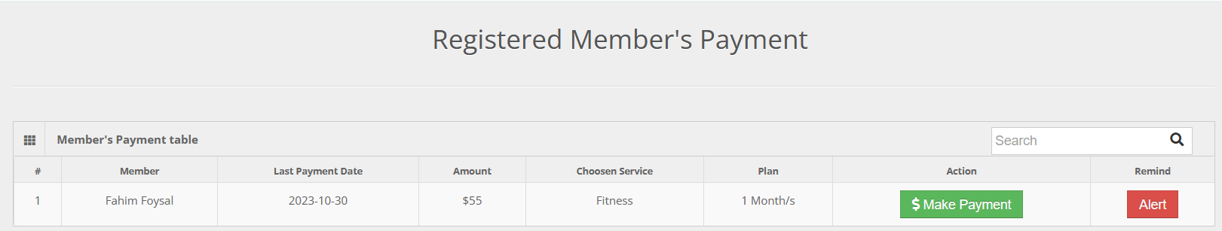

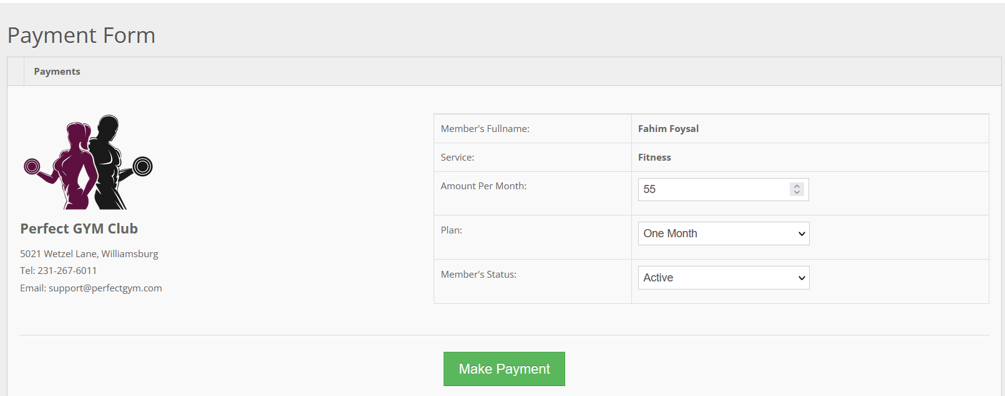

1. **Conclusion and Limitation**

**Bangladesh IT (Information Technology) sector is developing day by day. In every sector, online service is essential. This project helps those members who don’t come to first time gym house. It’s also help trainer to communicate student and give task regularly. That ways we can reduce time and easily submit proposal.**

**Complex development process. The development process for a gym management software can be quite complex, which may cause delays and challenges when launching and growing your product. Your gym management software will require a long-term investment due to the need for updates, bug fixes, and security vulnerabilities.**